**Market structure**

**Market-**

* Ordinarily the term market refers to a particular place, where goods are purchased and sold.
* In economics, the term market does not mean a particular place, but the whole area where buyer and sellers are spread.
* **In the words of A. A. Cornot :**

“Economist understand by the term market not any particular place in which things are bought and sold. But the whole of any region in which buyers and sellers are in such intercourse with one another that the price of the same goods tends to equality, easily and quickly.”

* Moreover in economics a market is not related to a place but to a particular product.
* Hence there separate market for various commodities ex- there are separate markets for clothes, grains, Jewelry, stock-market etc.

**Market Structure:-**

The structure of market both for goods and services are determined by the following factors.

1. **The no. and nature of buyers & sellers –** structure depend on buyer and sellers
2. **Nature of the product –** differential product, homogeneous product.
3. **Competition among the firms –** degree of competition also defines the structure of market.

**Types of market structure**

* There are quite a few different market structures that can characterize an economy.
* However, there are four basic types of market structures, which are very important.

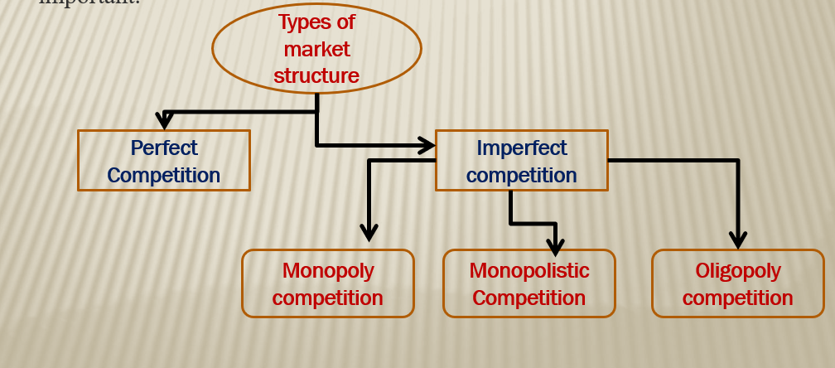

1. **Perfect competition market**

* Perfect competition describes a market structure where a large no. of small firms compete with each other.
* In this scenario, a single firm does not have any significant market power.
* As a result the industry as a whole produces the socially optimal level of output.
* Because none of the firms have the ability to influence market prices.
* The idea of a perfect competition builds on a no. of assumptions:-

1. All firms maximize their profits.
2. There is free entry & exit to the market.
3. All firms sell completely identical i.e. homogeneous products.
4. There are no consumer preference.

* By looking at those assumptions it becomes quite obvious that we will hardly ever find perfect competition in the reality.

**According to Boulding:-**

“A perfect competition market may be defined as a large no. of buyers & sellers, all engaged in the purchase & sale of identically similar commodities, who are in close contact with one another & who buy & sell freely among themselves.”

**Characteristics of Perfect Competition:-**

**i. Large no. of buyers and sellers –** no. of buyers & sellers must be so large that none of them can influence either price or supply and demand of the product.

1. **Homogenous product –** each firm produces and sells homogeneous product so that no buyer has any preference for product of any particular seller and no seller can have independent price policy.
2. **Perfect knowledge of market condition –** buyers & sellers are in close contact and have complete knowledge of prevailing price in the market and also the price at which others are prepare to buy & sell.

**iv. Freedom of entry & exit -** Whenever industry is earning excess profit any firm can enter in industry and whenever industry is making loss firms are free to leave industry.

1. **Uniform price -** as all products are homogeneous no firm should have independent price policy, means no firm can influence the price. If any seller does so the buyer will switch to seller with lower price.
2. **Absence of transport cost-** there is no transport cost in carrying a product from one place to another.

Probably the best example of a market with almost perfect competition, we can find in reality in the stock market.

1. **Imperfect competition**

* Imperfect competition is most common type of market structure.
* By definition imperfect competition is one that lacks conditions needed for perfect competition.
* The most common examples of imperfect competition are Monopoly, Monopolistic & Oligopoly.
* The competition which does not satisfy one or more conditions attached to the perfect competition is imperfect competition.
* Under this type of competition the firms can easily influence the price of a product in the market and reap surplus profits.
* In the real world it is hard to find perfect competition in any industry, but their Are so many industries like- telecommunication, automobile, soaps, cosmetics, detergents, cold drinks and technology where you can find imperfect competition.
* By the virtue of this, imperfect competition is also a real world competition.

“imperfect competition is a competition where, there are many sellers , but they are selling heterogeneous products as opposed to the perfect competition market scenario.”

* Under imperfect competition there are large no. of buyers & sellers or they can be few also.
* Each seller can follow its own price policy.
* Each producer produces differentiated product which are close substitute of each other.

**2(a). Monopoly Market**

* A monopoly refers to the market structure where a single firm controls the entire market.
* In this scenario firms have highest market power, as consumers do not have any alternative.
* As a result, monopolist often reduce output to increase price and earn more profits.
* **The following assumptions are made for a monopoly market:-**

1. **The monopolist maximizes profit.**
2. **It can set the price.**
3. **There are high barriers to entry & exit.**
4. **There are only one firm that dominates the entire market.**

* From the perspective of society, most monopolies are not desirable, because they result in lower output and higher prices compare to competitive markets.

**2(b). Monopolistic market**

* It refers to a market structure, where a large no. of firms compete against each other.
* However, unlike perfect competition the firms in monopolistic competition sell similar but slightly differentiated products.
* This gives them a certain degree of market power, which allows them to charge higher prices within a certain range.
* **Monopolistic competition builds on the following assumptions:-**

1. **All firms maximize profit.**
2. **There is free entry & exit to the market.**
3. **Firms sell differentiated products.**
4. **Consumer may prefer one product over other.**

**2(c). Oligopoly market**

* An oligopoly describes a market structure which is dominated by only a small no. of firms.
* this results in a state of limited competition, the firms can either compete against each other or collaborate.
* By doing so they can use their collective market power to drive-up prices and earn more profit.
* **The oligopolistic market structure builds on following assumptions:-**

1. **All firms maximize profit.**
2. **Oligopolies can set prices.**
3. **There are barriers to entry & exit in the market.**
4. **Products may be homogeneous or differentiated.**
5. **There are only a few firms that dominate the market.**

* Unfortunately, it is not clearly defined what a few firms means exactly.
* As a rule of thumb, we say that an oligopoly typically consists of about 3-5 dominant firms.

**Summery of different market structures**

|  |  |  |  |  |
| --- | --- | --- | --- | --- |
| **Characteristics of market type** | **Monopoly** | **Oligopoly** | **Monopolistic** | **Perfect Competition** |
| **No. of firms** | **one** | **few** | **many/several** | **Large no.** |
| **Freedom of entry & exit** | **Almost blocked** | **restricted** | **No restriction** | **No restriction** |
| **Nature of the Product** | **unique** | **Homogeneous/heterogeneous** | **Heterogeneous** | **Homogeneous** |
| **Average size of firms** | **Very large** | **Large** | **Small** | **Small** |
| **Control over price** | **Total control** | **Significant** | **Some or few** | **none** |
| **Price elasticity** | **Highly inelastic** | **Inelastic** | **Elastic** | **Highly elastic** |
| **Govt. intervention** | **Very high** | **High** | **Minimal** | **Minimal** |

**Price determination under perfect competition**

As we know that, firms in perfect competition market are price taker not a price maker. Means price under perfect competition is not determined by firms but external forces like supply and demand.

* **Sellers tend to supply more at high prices and less at lower prices.**
* **Similarly, buyers demand more at lower prices and less at higher prices.**

But there will be a point where quantity supplied and quantity demand will be equal. That point is called **Equilibrium point**  and the price of product at equilibrium point is **Equilibrium price.**

**Demand and Supply Schedule**

|  |  |  |
| --- | --- | --- |
| **Price** | **Quantity Demanded** | **Quantity Supplied** |
| 18  16  14 | 1000  2000  3000 | 7000  6000 (Supply>Demand)  5000 |
| **12** | **4000** | **40 (Equilibrium)** |
| 10  8  6 | 5000  6000  7000 | 3000  2000 (Supply<Demand)  1000 |

**Here in above schedule, at a price of Rs. 12 demand and supply both are equal means it is the equilibrium point and Rs. 12 is equilibrium price.**

**Equilibrium curve**

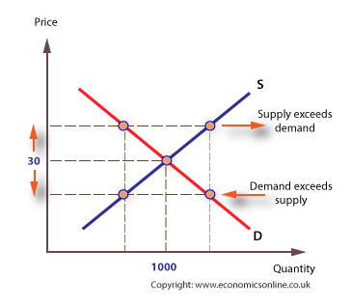

**PRICE DETERMINATION UNDER MONOPOLISTIC COMPETITION**

Under monopolistic competition, the firm will be in equilibrium position when marginal revenue is equal to marginal cost. So long the marginal revenue is greater than marginal cost, the seller will find it profitable to expand his output, and if the MR is less than MC, it is obvious he will reduce his output where the MR is equal to MC. In short run, therefore, the firm will be in equilibrium when it is maximizing profits, i.e., when MR = MC.

**(a) Short Run Equilibrium**

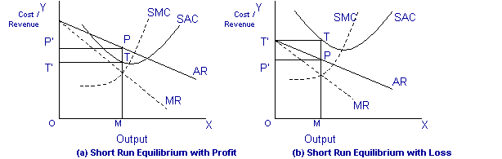

In the above diagram, the short run average cost is MT and short run average revenue is MP. Since the AR curve is above the AC curve, therefore, the profit is shown as PT. PT is the supernormal profit per unit of output. Total supernormal profit will be measured by multiplying the supernormal profit to the total output, i.e. PT × OM or PTT’P’ as shown in figure (a). The firm may also incur losses in the short run if it is facing AR curve below the AC curve. In figure (b) MP is less than MT and TP is the loss per unit of output. Total loss will be measured by multiplying loss per unit of output to the total output, i.e., TP × OM or TPP’T’.

**(b) Long Run Equilibrium**

Under monopolistic competition, the supernormal profit in the long run is disappeared as new firms are entered into the industry. As the new firms are entered into the industry, the demand curve or AR curve will shift to the left, and therefore, the supernormal profit will be competed away and the firms will be earning normal profits. If in the short run firms are suffering from losses, then in the long run some firms will leave the industry so that remaining firms are earning normal profits.

The AR curve in the long run will be more elastic, since a large number of substitutes will be available in the long run. Therefore, in the long run, equilibrium is established when firms are earning only normal profits. Now profits are normal only when AR = AC. It is further illustrated in the following diagram:

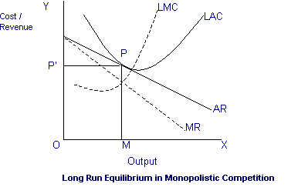

**Price and Output Determination under Duopoly:**

***(a)***    If an industry is composed of two giant firms each selling ***identical or homogenous*** products and having half of the total market, the price and output policy of each is likely to affect the other appreciably, therefore there is every likelihood of ***collusion*** between the two firms. The firms may agree on a price, or divide the total market, or assign quota, or merge themselves into one unit and form a monopoly or try to differentiate their products or accept the price fixed by the leader firm, etc.

***(b)***   In case of ***perfect substitutes***the two firms may be engaged in ***price competition.*** The firm having lower costs, better goodwill and clientele will drive the rival firm out of the market and then establish a monopoly.

***(c)***    If the products of the Duopolists are ***differentiated,***each firm will have a close watch on the actions of its rival firms. The firm good quality product with lesser cost will earn abnormal profits. Each firm will fix the price of the commodity and expand output in accordance with the demand of the commodity in the market.

**Price and Output Determination under Oligopoly:**

***(a)***    If an industry is composed of few firms each selling ***identical or homogenous products*** and having powerful influence on the total market, the price and output policy of each is likely to affect the other appreciably, therefore they will try to promote ***collusion.***

***(b)***   In case there is ***product differentiation***, an Oligopolist can raise or lower his price without any fear of losing customers or of immediate reactions from his rivals. However, keen rivalry among them may create condition of ***monopolistic competition.***

There are set of theories like Cournot Duopoly Model, Bertrand Duopoly Model, the Chamberlin Model, the Kinked Demand Curve Model, the Centralised Cartel Model, Price Leadership Model, etc., which have been developed on particular set of assumptions about the reaction of other firms to the action of the firm under study. But there is no single theory which satisfactorily explains the oligopoly behavior regarding price and output in the market.

**National income**

National income is an uncertain term which is used interchangeably with national dividend, national output and national expenditure. On this basis, national income has been defined in a number of ways.

**“In common parlance, national income means the total value of goods and services produced annually in a country.”**

**Modern Definitions:** From the modern point of view, Simon Kuznets has defined national income as **“the net output of commodities and services flowing during the year from the country’s productive system in the hands of the ultimate consumers.”**

On the other hand, in one of the reports of United Nations, national income has been defined on the basis of the systems of estimating national income, as net national product, as addition to the shares of different factors, and as net national expenditure in a country in a year’s time.

**Concepts of National Income**

There are a number of concepts pertaining to national income and methods of measurement relating to them.

1. **Gross Domestic Product (GDP):** GDP is the total value of goods and services produced within the country during a year. This is calculated at market prices and is known as GDP at market prices.

**Dernberg defines** GDP at market price as “the market value of the output of final goods and services produced in the domestic territory of a country during an accounting year.”

***GDP = C+I+G+(X-M)***

Where, C= Consumption, I = Investment, G= Government Expenditure,

X= Export, M=Import

**Net Domestic Product (NDP):-** NDP is the value of net output of the economy during the year. Some of the country’s capital equipment wears out or becomes obsolete each year during the production process. The value of this capital consumption is some percentage of gross investment which is deducted from GDP. Thus

***Net Domestic Product (NDP)=GDP at Factor Cost – Depreciation.***

***\** GDP at Factor Cost = GDP at Market Price – Indirect Taxes + Subsidies**

**Gross National Product (GNP):** GNP is the total measure of the flow of goods and services at market value resulting from current production during a year in a country, including net income from abroad.

***GNP = C + I + G + (X-M) + NFIA***

* **Net factor income from abroad (NFIA)= Factor income earned by our residents from the rest of the world - Factor income earned by non- residents in our domestic territory**

**Net National Product (NNP):** NNP includes the value of total output of consumption goods and investment goods. But the process of production uses up a certain amount of fixed capital. Some fixed equipment wears out, its other components are damaged or destroyed, and still others are rendered obsolete through technological changes.

All this process is termed depreciation or capital consumption allowance. In order to arrive at NNP, we deduct depreciation from GNP.

So, ***NNP = GNP—Depreciation****.*

*OR*

***NNP = C + I + G + (X-M) + NFIA – Depreciation***

**Per Capita Income:** The average income of the people of a country in a particular year is called Per Capita Income for that year. This concept also refers to the measurement of income at current prices and at constant prices. For instance, in order to find out the per capita income for 2001, at current prices, the national income of a country is divided by the population of the country in that year.



This concept enables us to know the average income and the standard of living of the people. But it is not very reliable, because in every country due to unequal distribution of national income, a major portion of it goes to the richer sections of the society and thus income received by the common man is lower than the per capita income.

**Personal Income:** Personal income is the total income received by the individuals of a country from all sources before payment of direct taxes in one year. Personal income is never equal to the national income, because the former includes the transfer payments whereas they are not included in national income.

**Disposable Income:** Disposable income or personal disposable income means the actual income which can be spent on consumption by individuals and families. The whole of the personal income cannot be spent on consumption, because it is the income that accrues before direct taxes have actually been paid. Therefore, in order to obtain disposable income, direct taxes are deducted from personal income. Thus

***Disposable Income=Personal Income – Direct Taxes***

**Methods of Measuring National Income:**

There are four methods of measuring national income. Which method is to be used depends on the availability of data in a country and the purpose in hand.

**(1) Product Method:-** According to this method, the total value of final goods and services produced in a country during a year is calculated at market prices. To find out the GNP, the data of all productive activities, such as agricultural products, wood received from forests, minerals received from mines, commodities produced by industries, the contributions to production made by transport, communications, insurance companies, lawyers, doctors, teachers, etc. are collected and assessed at market prices. Only the final goods and services are included and the intermediary goods and services are left out.

**(2) Value Added Method:-** Another method of measuring national income is the value added by industries. The difference between the value of material outputs and inputs at each stage of production is the value added. If all such differences are added up for all industries in the economy, we arrive at the gross domestic product.

**(3) Income Method:-** According to this method, the net income payments received by all citizens of a country in a particular year are added up, i.e., net incomes that accrue to all factors of production by way of net rents, net wages, net interest and net profits are all added together but incomes received in the form of transfer payments are not included in it. The data pertaining to income are obtained from different sources, for instance, from income tax department in respect of high income groups and in case of workers from their wage bills.

**(4) Expenditure Method:-** According to this method, the total expenditure incurred by the society in a particular year is added together and includes personal consumption expenditure, net domestic investment, government expenditure on goods and services, and net foreign investment. This concept is based on the assumption that national income equals national expenditure.

**Inflation**

**Inflation is the decline of purchasing power of a given currency over time.** A quantitative estimate of the rate at which the decline in purchasing power occurs can be reflected in the increase of an average price level of a basket of selected goods and services in an economy over some period of time. The rise in the general level of prices, often expressed as a percentage, means that a unit of currency effectively buys less than it did in prior periods.

Inflation exists when money supply exceeds available goods and services. Inflation is the rate at which the value of a currency is falling and consequently the general level of prices for goods and services is rising.

Inflation may be defined as **‘a sustained upward trend in the general level of prices’ and not the price of only one or two goods.**

G. Ackley defined inflation **as ‘a persistent and appreciable rise in the general level or aver­age of prices’**. In other words, inflation is a state of rising prices, but not high prices.

**Types of Inflation:**

Inflation may be caused by a variety of factors. Its intensity or pace may be different at different times. It may also be classified in accordance with the reactions of the government toward inflation.

1. **On the Basis of Speed or Intensity:**

**1. Creeping Inflation**:- Inflation is a rise in the general level of prices of goods and services over a period of time. In everyday lingo, it is usually associated with steep price increases, but in fact refers to any increase, however big or small.

Creeping inflation is defined as the circumstance where the inflation of a nation increases gradually, but continually, over time. The relatively small effect of creeping inflation, when viewed long-term, actually adds up to a pretty significant increase in the cost of living.

**If the prices increase by 3% or less annually, then such inflation is creeping inflation.**

**2. Walking inflation:-** When the price rise is moderate (is in the range of 3 to 7 %) and the **annual inflation rate is of a single digit,** it is called walking inflation. It is a warning signal for the government to control it before it turns into running inflation.

**3. Galloping inflation;-** refers to a condition when the inflation rate is extraordinarily high. It is perhaps 20%, 50%, or even higher on an annual basis. In this period, out of control inflation exacerbates an economic recession.

**4. Hyperinflation:-** is a term to describe rapid, excessive, and out-of-control general price increases in an economy. While inflation is a measure of the pace of rising prices for goods and services, hyperinflation is rapidly rising inflation, typically measuring more than 50% per month.

Although hyperinflation is a rare event for developed economies, it has occurred many times throughout history in countries such as China, Germany, Russia, Hungary, and Argentina.

**B. On the Basis of Causes:**

1. **Demand-pull inflation:-** An increase in aggregate demand over the available output leads to a rise in the price level. Such inflation is called demand-pull in­flation (henceforth DPI).
2. **Cost-push inflation:-** Inflation in an economy may arise from the overall increase in the cost of production. This type of inflation is known as cost-push inflation (henceforth CPI).

**Causes of Inflation:**

Inflation is mainly caused by excess demand/ or decline in aggregate supply or output. Former leads to a rightward shift of the aggregate demand curve while the latter causes aggregate supply curve to shift left­ward. Former is called demand-pull inflation (DPI), and the latter is called cost-push infla­tion (CPI). Before describing the factors, that lead to a rise in aggregate demand and a de­cline in aggregate supply, we like to explain “demand-pull” and “cost-push” theories of inflation.

**(i) Demand-Pull Inflation Theory:-** There are two theoretical approaches to the DPI—one is classical and other is the Keynesian.

According to classical economists or monetarists, inflation is caused by an increase in money supply which leads to a rightward shift in negative sloping aggregate demand curve. Given a situation of full employment, classicists maintained that a change in money supply brings about an equi-proportionate change in price level.

**Main causes of Demand-Pull Inflation:**

1. **Cut in interest rates:** lower interest on loans will promote public to take more loans and hence will increase their purchasing capacity which will lead to increase in demand.
2. **Increased money supply:-** any monetary policy of government which leads to increase in money supply will increase purchasing capacity of public and will cause to increased demand.
3. **Higher wages:-** increase in wages or salary directly leads to increased purchasing power of consumer hence cause to increased demand.

**(ii)Cost-Push Inflation Theory:** In addition to aggregate demand, aggregate supply also generates inflationary process. As inflation is caused by a leftward shift of the aggregate supply, we call it CPI. CPI is usu­ally associated with non-monetary factors. CPI arises due to the increase in cost of produc­tion. Cost of production may rise due to a rise in cost of raw materials or increase in wages.

**Causes of Cost-Push Inflation:**

1. **Monopoly:-** Companies that achieve a **monopoly** over an industry can create cost-push inflation. A monopoly reduces supply to meet its profit goal.
2. **Wage inflation:-** Wage inflation occurs when workers have enough leverage to force through wage increases. Companies then pass higher costs through to consumers.
3. **Natural Disasters:-** Natural disasters cause inflation by disrupting supply. A good example is right after Japan's earthquake in 2011. It disrupted the supply of auto parts.
4. **Government Regulation and Taxation:-** A fourth driver is government regulation and taxation. These rules can reduce supplies of many other products. Taxes on cigarettes and alcohol were meant to lower demand for these unhealthy products. That may have happened, but more importantly, it raised the price and created inflation.
5. **Exchange Rates:-** The fifth reason is a shift in **exchange rates**. Any country that allows the value of its currency to fall will experience higher import prices. The foreign supplier does not want the value of its product to drop along with that of the currency. If demand is inelastic, it can raise the price and keep its profit margin intact.

**Methods to Control Inflation**

Inflation is generally controlled by the Central Bank and/or the government. The main policy used is monetary policy (changing interest rates). However, in theory, there are a variety of tools to control inflation including:

1. **Monetary policy:-** Higher interest rates reduce demand in the economy, leading to lower economic growth and lower inflation.
2. **Control of money supply:-** Monetarists argue there is a close link between the money supply and inflation, therefore controlling money supply can control inflation.
3. **Supply-side policies** :- policies to increase the competitiveness and efficiency of the economy, putting downward pressure on long-term costs.
4. **Fiscal policy:-** a higher rate of income tax could reduce spending, demand and inflationary pressures.
5. **Wage controls:-** trying to control wages could, in theory, help to reduce inflationary pressures. However, apart from the 1970s, it has been rarely used.
6. **Compulsory Saving:-** The government may start schemes of compulsory savings to take from each person some portion of his earnings. The purpose is to decrease the purchasing power of each person.
7. **Public Debt:-** The government may arrange public debt during inflation. The central bank can arrange loans from banks and the general public. The borrowing on the part of the government reduces the income of people.
8. **Tariff Decrease:-** The decrease in tariff on importers encourages the importers to buy goods in large quantities from other countries. The low rate permits import of goods at a low rate.
9. **Check on Exports:-** The surplus goods may be exported, but the items which are short at the home market should not be exported at any cost. The maintenance of a stable price level is a challenge for the government.
10. **Others:-** Control Over Investment, Price Control, Increase in Production etc.

**Business Cycle**

A business cycle is a cycle of fluctuations in the Gross Domestic Product (GDP) around its long-term natural growth rate. It explains the expansion and contraction in economic activity that an economy experiences over time.

A business cycle is completed when it goes through a single boom and a single contraction in sequence. The time period to complete this sequence is called the length of the business cycle. A boom is characterized by a period of rapid economic growth whereas a period of relatively stagnated economic growth is a recession.

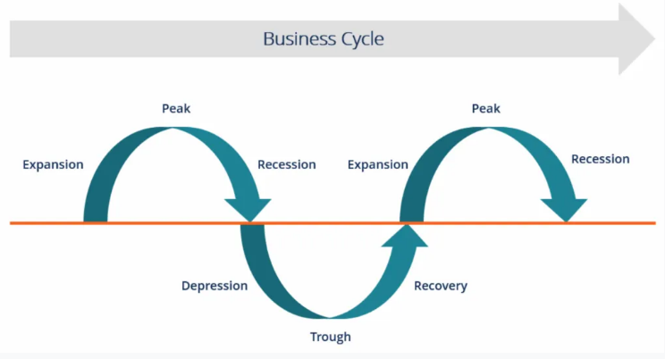

**Stages of the Business Cycle**

In the diagram above, the straight line in the middle is the steady growth line. The business cycle moves about the line.  Below is a more detailed description of each stage in the business cycle:

**1. Expansion:-** The first stage in the business cycle is expansion. In this stage, there is an increase in positive economic indicators such as employment, income, output, wages, profits, demand, and supply of goods and services. Debtors are generally paying their debts on time, the velocity of the money supply is high, and investment is high. This process continues as long as economic conditions are favorable for expansion.

**2. Peak:-** The economy then reaches a saturation point, or peak, which is the second stage of the business cycle. The maximum limit of growth is attained. The economic indicators do not grow further and are at their highest. Prices are at their peak. This stage marks the reversal point in the trend of economic growth. Consumers tend to restructure their budgets at this point.

**3. Recession:-** The recession is the stage that follows the peak phase. The demand for goods and services starts declining rapidly and steadily in this phase. Producers do not notice the decrease in demand instantly and go on producing, which creates a situation of excess supply in the market. Prices tend to fall. All positive economic indicators such as income, output, wages, etc., consequently start to fall.

**4. Depression:-** There is a commensurate rise in unemployment. The growth in the economy continues to decline, and as this falls below the steady growth line, the stage is called depression.

**5. Trough:-** In the depression stage, the economy’s growth rate becomes negative.. There is further decline until the prices of factors, as well as the demand and supply of goods and services, reach their lowest point. The economy eventually reaches the trough. It is the negative saturation point for an economy. There is extensive depletion of national income and expenditure.

**6. Recovery:-** After this stage, the economy comes to the stage of recovery. In this phase, there is a turnaround from the trough and the economy starts recovering from the negative growth rate. Demand starts to pick up due to the lowest prices and, consequently, supply starts reacting, too. The economy develops a positive attitude towards investment and employment and production starts increasing.

Employment begins to rise and, due to accumulated cash balances with the bankers, lending also shows positive signals. In this phase, depreciated capital is replaced by producers, leading to new investments in the production process.

Recovery continues until the economy returns to steady growth levels. It completes one full business cycle of boom and contraction. The extreme points are the peak and the trough.